Linda Brodsky Memorial Journal

**Math to Medicine: Building a Community**

*Azlan Tubbs*

In first grade, we completed math packets with addition and subtraction problems filling each page. My small hands eagerly accepted these packets, and at the end of each week, numbers and symbols filled the pages in my scrawling handwriting. I became the girl my classmates approached with their questions, and together, we learned the foundations of math.

As the years passed, my love for math grew. I took every available math class offered in high school, and I fell in love with the way I viewed the world through math: as something to be understood, appreciated, and modeled imperfectly.

My interest in math accompanied a growing realization that I was a woman in math. The concept of gender disparity in STEM fields was first introduced to me in middle school as I attended a Denver Girls

in STEM convention. While I enjoyed learning engineering and science from the women volunteers, I could not yet grasp the concept that the world historically viewed women differently than men.

In college, gender disparity sharpened. Women filled the front row of my physics class, and men occupied the remainder of the lecture hall behind us. I refereed intramural sports beside male coworkers for four years. My math classes were filled with the names of famous mathematicians: Fourier, Gauss, Cauchy, Euler, all men who contributed greatly to the field. My professors addressed mathematics’ gender gap, noting women where they could but finding few opportunities to do so.

Though men dominated the student numbers at my college, there were initiatives and organizations for women, and I found where I belonged. In particular, the Society of Women Engineers (SWE) taught me what it was to be a woman in STEM. While presenting me with tools and knowledge to recognize my worth, SWE showed me the value of mentorship, leadership, and perhaps most important of all, community.

It is the community of women I have found, both in math and medicine, with students and professionals, who have inspired me most, minimize gender gaps, and continue to advocate for gender equity.

SWE gave me experiences in leadership and event planning as I created opportunities for younger girls to learn more about STEM, and I shared engineering with girls around Colorado through many interactive events, panels, and outreach days. SWE volunteers and I spread our passions for STEM to the next generation of women engineers.

Joining AMWA’s national premedical division gave me a community of women physician mentors I needed to envision myself in medicine. They encouraged my vision and dream, and I saw myself reflected in the career I aspired to enter. Representation matters, and AMWA physicians broadened my horizons and deepened my quest for this career. I felt empowered to create my own AMWA premedical branch, take the MCAT, apply to medical school, and move 500 miles from home.

Countless women preceded me, giants who fought for suffrage, rights, and equity. As my love for medicine outpaced my love for math, I recognized how women paved the way in both professions. I was a student of math and medicine, and I was not alone.

I was a *woman* in math and medicine, and I could contribute to gender equity in my own way. As women had done before me, I could make the world a better place for women who would come after me.

When I moved to Texas for medical school, the gender ratio of my class shocked me. Instead of glancing around and seeing a majority of men, I saw a near-even division. I remembered SWE’s lessons of wage gaps, unpaid domestic labor, and the need for mentorship, advocacy, and women in leadership positions.

I lived in a new place and attended a new school, but I did what I knew: I formed a committee of medical students, invited high school girls in Lubbock and surrounding rural communities, and hosted our first annual AMWA Outreach Day at TTUHSC. With medical students, men and women alike, demonstrating medical applications that ranged from blood pressure to CPR to ultrasounds and women physicians speaking as panelists, we demonstrated how women belonged in medicine. As high school students spoke with us, I could see a dream of their future in their eyes, just as I had when I discovered medicine and AMWA’s community. When high school girls asked a surgeon about her path into medicine, I saw my past and my future before me.

I will always be an advocate for women in STEM and medicine, and I will continue to create opportunities for younger girls to walk paths of their own making.

Gender equity is about giving women the opportunities and abilities they need to succeed. There is a difference between admiring a career and thinking, “I want to do that,” and believing with one’s whole heart, “I can and will do that.” Gender equity encourages women to realize their dreams, even if no woman has gone before them. Through advocating for women-focused legislative policy, supporting women-owned businesses, mentoring young students and professionals, and publicizing women’s accomplishments, women controlling their voices and amplifying their words is a huge step in gender equity.

As a first grader equipped with a math packet, I would have no idea how much gender equity would mean to me one day. That girl with the braids in her hair grew into a medical student with fire in her heart (in addition to the braids). Though we face obstacles and barriers in many aspects of our lives, women have a strength and determination like no other. Our tenacity, courage, and love will inspire and empower women of all generations and change the world.

**Biography**

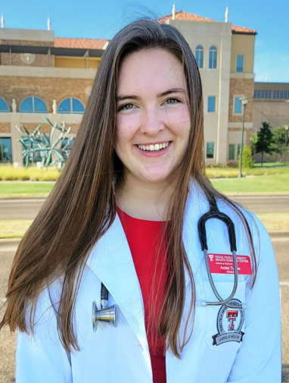

Azlan Tubbs is a second-year medical student at the Texas Tech University Health Sciences Center School of Medicine. She completed her bachelor’s degree in applied mathematics and statistics from Colorado School of Mines, where she was president of the Society of Women Engineers. In 2020, she joined AMWA, discovering inspiration and mentors that empowered her to apply to medical school and found a premedical AMWA branch. She has a passion for supporting and elevating women in STEM fields, and she enjoys participating in advocacy initiatives and mentorship opportunities. In her free time, she reads, practices piano, plays soccer, paints, and spends time with her family and friends.